Combination of Systems Engineering Ontology and Model-based Systems Engineering Ontology: IOF Approach

Author’s Name (only one author) Author’s Name (first of many)

Organization Organization

Mailing Address Mailing Address

Telephone Telephone

[*author.one@gmail.com*](mailto:author.one@gmail.com)[*author.one@gmail.com*](mailto:author.one@gmail.com)

Author’s Name (only one author) Author’s Name (first of many)

Organization Organization

Mailing Address Mailing Address

Telephone Telephone

[*author.one@gmail.com*](mailto:author.one@gmail.com)[*author.one@gmail.com*](mailto:author.one@gmail.com)

Author’s Name (only one author) Author’s Name (first of many)

Organization Organization

Mailing Address Mailing Address

Telephone Telephone

[*author.one@gmail.com*](mailto:author.one@gmail.com)[*author.one@gmail.com*](mailto:author.one@gmail.com)

Author’s Name (only one author) Author’s Name (first of many)

Organization Organization

Mailing Address Mailing Address

Telephone Telephone

[*author.one@gmail.com*](mailto:author.one@gmail.com)[*author.one@gmail.com*](mailto:author.one@gmail.com)

Author’s Name (only one author)

Organization

Mailing Address

Telephone

[*author.one@gmail.com*](mailto:author.one@gmail.com)

Copyright © 202X by Author Name. Permission granted to INCOSE to publish and use.

**Abstract**. This paper proposes an overview of Systems Engineering (SE) ontology and Model-based Systems Engineering (MBSE) ontology based on the Basic Formal Ontology (BFO) and Industrial Ontologies Foundry (IOF) core specification by IOF systems engineering working group. Currently, there are considerable number of system related and model related ontology which are often not compatible with each other within the systems engineering and other domain specific communities. To address this issue, IOF systems engineering working group is setting up to define the SE ontology and MBSE ontology based on BFO and IOF core ontology to facilitate ontology integration among different systems engineering domains from the perspective of ontology engineering. The current effort is related to the basic SE and MBSE taxonomy based on the top level ontology in order to streamline the unified representation among real system and their virtual models. The ontology is illustrated through an example of an autonomous driving system.

# Introduction

Since the new technical evolution of Information and Communications Technology (ICT) and embedded systems, engineered systems are becoming highly complexity by increasing interactions among different mechatronic components and software which enables to provide more complex functions to their users (Nilsson et al. 2020). This brings more communication and negotiation among the stakeholders from different domains. However, lack of a unified common understanding of each specific concept across different domains results in potentially dire consequences because of misunderstanding (Dori and Sillitto 2017). Moreover, such raising components and interactions lead to the needs to the capability to manage the system complexity efficiently and effectively. Thus, unified ontology concepts enables to create a unified representation of domain specific taxonomy with a rational topology to define the complexity for management.

Since digitalization such as digital twin, model-based systems engineering etc., is provided as a new technical tendency for systems engineering community, digital models are used across the entire system lifecycle. When developing a seamless environment for the entire system development process, ontology is considered as a solution to integrate heterogeneous model as middle-ware. Through its specific data structure, semantic reasoning and query enable to provide a knowledge management solution for system developers. However, such digital models always represent real system bringing challenges to synthesize the real system and its models which can be shared and recognized by stakeholders or computers.

Thus, our effort is to investigate an ontology engineering approach to define the systems engineering (SE) ontology and MBSE ontology based on a top-level ontology. The final proposed ontology is expected to realize the following objectives:

* The communications among different domain specific communities to achieve the common understanding which is prevented based on a top level ontology;
* Describe the ontology concept of the real system and its virtual models in order to clarify the topology among them;
* The ontology is expected to become the basic middle-ware between human and AI-based machines. Semantic reasoning based on this ontology enables to provide deep analysis of real system and its models.

The reminder of the paper is structured as follows. The related work related to the systems engineering and model-based systems engineering ontology is explored in Section 2. The proposed research methodology is introduced in Section 3 and this paper focus on the systems engineering ontology concept which is shown in Section 4. In Section 5, a case study of autonomous driving system is illustrated. Then Section 6 providers the discussion and limitations of this study. Finally, the conclusion is offered in Section 7.

# Related Work

In philosophical contexts, “ontology” has traditionally been defined as the nature of what exists (or of “being qua being”): the study of the kinds of entities in reality and of the relationships that these entities bear to one another (Arp et al. 2016). In this paper, we define ontology as a representational artifact, comprising a taxonomy as proper part, whose representations are intended to designate some combination of universals, defined classes, and certain relations between them. Currently, ontology is widely used in the area of systems engineering and model-based systems engineering (Li et al. 2022). As shown in Figure 1-A, among 4675 MBSE papers in the SCOPUS, ontology has been considered as the main topic in the domain of MBSE. Moreover, Figure 1-B demonstrates the ontology is the future tendency of systems engineering in the last five years through the thematic evolution analysis. In the core journal articles of IEEE and INCOSE, ontology is an important key word among 143 journal articles (Dong et al. 2022).

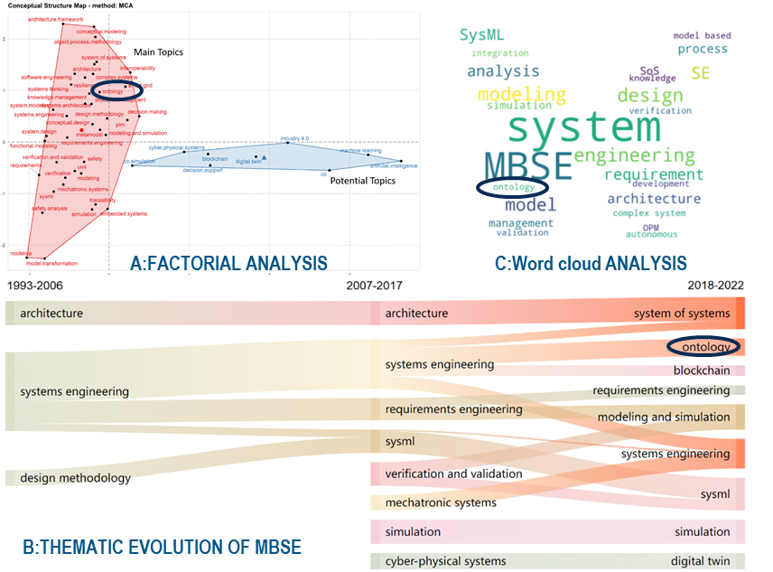

Figure 1 Bibliometric analysis in model-based systems engineering (Li et al. 2022)(Dong et al. 2022)

In order to review the literatures of this paper, we hope to identify the papers focusing not only on systems engineering but also on model-based systems engineering (Henderson and Salado 2020),. Thus, the authors search "system ontology" (search configuration: anywhere) and "system engineering ontology" (search configuration: anywhere) and "MBSE ontology" (search configuration: anywhere) and "model-based systems engineering ontology" (search configuration: anywhere) in INCOSE Wiley[1]. From the result, we find there are 98 results since 2002, including 38 INCOSE International Symposium papers, 35 INSIGHT journal articles, and 25 Systems Engineering journal articles.

From the review of such papers，we find industries such as ESA (Karban et al. 2012) and NASA (Bayer et al. 2012) made use of ontology and MBSE to support their system development since 2014. First, ontology is always represented based on the graphical modeling approaches, for example minimal universal ontology OPM (Levenchuk 2009) and PROVE (Shaked and Reich 2019) were proposed to support system formalism using graphical notations. Moreover, ontology was considered as SysML models in some papers (Strengers 2014). Second, ontology is developed to support system formalism from engineered system perspective which is used to support MBSE including model formalism (Fisher et al. 2014), requirement formalism (Fanmuy et al. 2010), safety formalism (Petnga et al. 2017) and project plan (Sharon et al. 2009). Third, when the ontology models were developed, model checking was used to support system analysis by semantic reasoning (Menshenin and Crawley 2020).

Except for formalism, ontology is also proposed to promote the interoperability among different domains across the entire lifecycle. First, ontology was used to support meta model development in order to integrate the domain specific knowledge from different perspectives (Friedenthal 2016). Second, some researchers thought it was required to create a bridge from domain specific ontology into MBSE ontology (Levenchuk 2009). Moreover, model transformation was always used for generating ontology models from MBSE models. Finally, some researchers proposed ontology enables to define the connections among SysML and real system which is considered as an abstract of models (Madni 2015).

In summary, ontology is required to formalize not only real system but also virtual model. A “bridge” is required to integrate ontology for MBSE and SE in order to realize a unified ontology model. This ontology is also expected to support semantic reasoning for implementing analysis for system development.

# Overview of IOF Systems Engineering and MBSE Ontology

In this paper, an ontology framework is proposed by Industrial Ontologies Foundry (IOF)[2] systems engineering working group for .

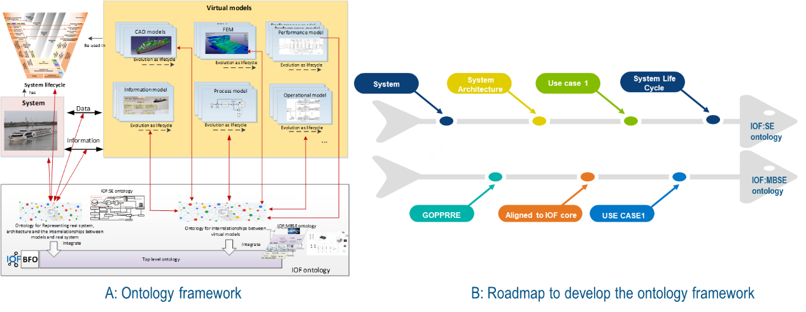

Figure 2 A: Ontology framework; B: Ontology development roadmap

**Ontology framework.** As shown in the figure, the proposed ontology is expected to support the formalism of real systems and their virtual models from the perspective of digital twins. First, system lifecycle, physical entities and their information flow and data flow with virtual entities are defined based on the IOF:SE ontology. The virtual entities, particularly focusing on the MBSE models currently, are represented by using IOF:MBSE ontology. Such two ontologies are defined under the top level ontology BFO and IOF core.

**Ontology development roadmap.** As shown in Figure 2, the two ontologies are developed through different lifecycle. From the perspective of IOF:SE ontology, system architecture and system concepts are first developed. Then through a use case, the developed ontology is evaluated. Then system lifecycle will be developed. From the perspective of IOF:MBSE ontology, a GOPPRRE ontology is proposed based on the MOF framework with meta-meta models including Graph, Object, Relationship, Role, Point, Property and extensions (Jinzhi Lu, Guoxin Wang). Then such ontology concepts are aligned to the BFO and IOF core. Finally, a use case will be implemented to evaluate the given ontology.



Figure 3 Ontology concepts based on BFO

**Ontology concepts based on top level ontology**. The ontology framework is developed based on top level ontology BFO and IOF core. In this paper, we are mainly focused on the IOF:SE ontology which is developed by the IOF SE working group. As shown in Figure 3, the red nodes are defined as top level ontology. The blue nodes, such as system, system boundary, interface and environment, etc. are developed as IOF:SE ontology based on the BFO framework. Moreover, IOF: MBSE ontology is defined as subclass of information content entity.

# IOF Systems Engineering Ontology Concepts

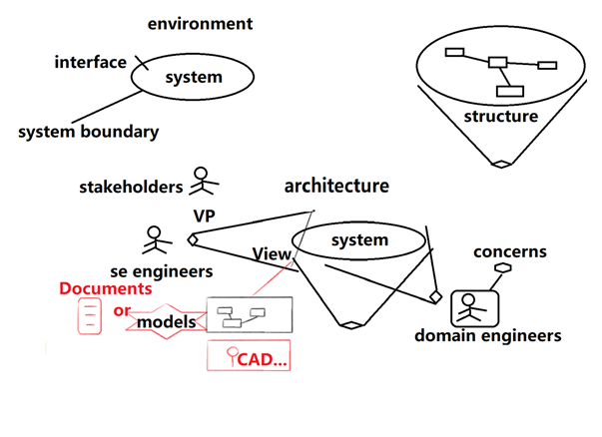

Figure 4 IOF:SE ontology overview

As shown in Figure 4, IOF:SE ontology currently is focus on three main topics: 1) system; 2) system architecture; 3) system structure. The topic related to system is mainly used to define the ontology concepts related to system, such as system boundary. The system architecture is focus on different views and viewpoints about the system described by stakeholders. Structure is focus on the topology among different system elements which construct the system.

Table 1 IOF:SE ontology concepts

|  |  |  |  |
| --- | --- | --- | --- |
| Ontology concept | IOF:SE definition | If the concepts are integrated with BFO in Figure 3 | If the concepts are confirmed by IOF SE working group |
| **System** | | | |
| System | Collection of elements in interaction. Definition applies to natural, social or technical systems. | √ | Confirmed |
| * Engineered system | System which is designed to provide certain capabilities. | √ | Confirmed |
| * + Input-process-output system | Engineered system whose function is to transform defined inputs into outputs | √ | Confirmed |
| * Social system | System whose elements are organisms. | √ | Confirmed |
| * + Socio-technical system | System whose elements include human-beings. | √ | Confirmed |
| System of systems | is a collection of systems which is itself a system. | Integrated but not confirmed | Confirmed |
| System Function | A disposition that exists in virtue of the bearer's physical make-up and this physical make-up is something the bearer possesses because it came into being either through evolution (in the case of natural biological entities) or through intentional design (in the case of artefacts), in order to realize processes of a certain sort. | √ | Confirmed |
| Environment | Collection of elements that are not in the system, and are interacting with the system. | √ | Confirmed |
| System Boundary | System boundary is the collections of elements of the system which interact with entities which are not part of the system.  To define the system or system boundary, we require the selection of:  1 specific collections of elements  2 specific elements types  3 specific interaction types between elements  4 specific outcome types  5 specific interaction types between elements and environment. | √ | Confirmed |
| System Interface | An element which is a part of the system boundary and has the function of interacting with entities outside the system. | √ | Confirmed |
| Interface Connector | The connector refers to a material entity that has two ends that can be inserted into interfaces in the other system. | √ | Confirmed |
| Interface Retainer | The retainer is a part of the system in as a material entity that as a site into which a connector can be inserted. | √ | Confirmed |
| Role | b is a role means: b is a realizable entity & b exists because there is some single bearer that is in some special physical, social, or institutional set of circumstances in which this bearer does not have to be & b is not such that, if it ceases to exist, then the physical make-up of the bearer is thereby changed. | √ | Confirmed |
| * Supersystem role | Role of system when viewed as having one or more systems as parts.  Comment: roles are always assigned by communities; the same community are responsible for the relevant views. | √ | Confirmed |
| * Subsystem role | Role of system when viewed as being part of a system.  Comment: roles are always assigned by communities; the same community are responsible for the relevant views. | √ | Confirmed |
| **Architecture** | | | |
| System architecture | Fundamental concepts or properties of a system in its environment embodied in its elements, relationships, and in the principles of its design and evolution (IEEE Standard 2011). | Temporarily not integrated | Not confirmed |
| Stakeholder | Individual or organization having a right, share, claim, or interest in a system or in its possession of characteristics that meet their needs and expectations (ISO/IEC/IEEE 2008). | √ | Not confirmed |
| Concern | The concern is System-of-Interest in a system relevant to one or more of its stakeholders (IEEE Standard 2011). | Temporarily not integrated yet | Not confirmed |
| View | A view of a system from a given aspect focuses on those features of the system which are defined by the aspect (Martin 2021) . | Temporarily not integrated yet | Not confirmed |
| Viewpoint | A specification of the conventions and rules for constructing and using a view for the purpose of addressing a set of stakeholder concerns (Martin 2021) . | Temporarily not integrated yet | Not confirmed |
| Perspective | The way of stakeholders’ thinking about an entity, especially as it relates to concerns (Martin 2021). | Temporarily not integrated yet | Not confirmed |
| Aspect | A refinement of concerns to capture a particular character or nature of a thing (Martin 2021) . | Temporarily not integrated yet | Not confirmed |
| **Structure** | | | |
| Structure | A physical layout of the components of a system design and their internal and external connections. | Temporarily not integrated | Not confirmed |
| System element | Element in the context of the above discussion means certainly something physical, perhaps just means BFO object. | Temporarily not integrated | Not confirmed |
| Interaction | A process in which two elements acts on each other by changing their qualities. | √ | Not confirmed |
| State | A state is the set of measurable values of the system’s non-invariant properties at a given time. | √ | Not confirmed |

# IOF Model-based Systems Engineering Ontology Concepts

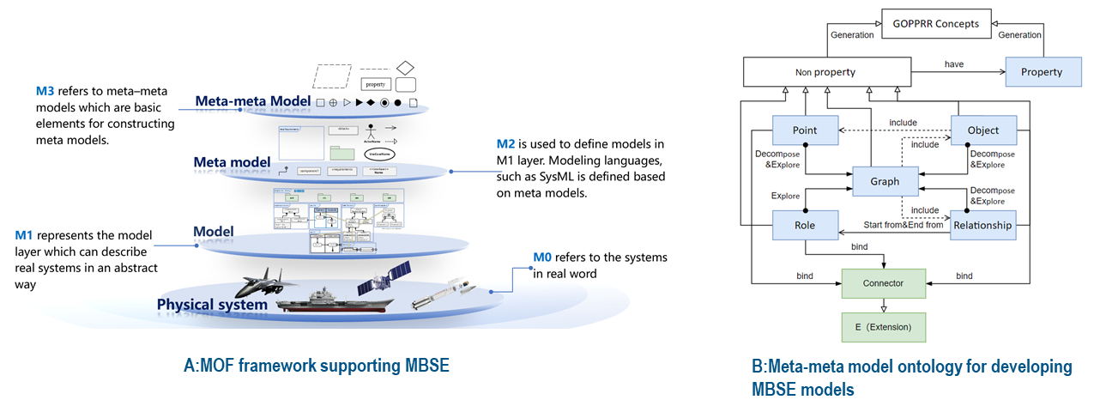

Figure 5 IOF:MBSE ontology overview

The IOF:MBSE ontology is a basic MBSE formalism based on the meta-object facility (MOF) framework whose meta-meta models include Graph, Object, Relationship, Role, Point and Property as shown in Figure 5:A. The MOF framework includes four layers:

* Meta-meta model refers to the fundamental elements to construct the meta-models.
* Meta-model is defined based on meta–meta models as the model compositions for developing models.
* Model is created based on meta-models aiming to formalize physical systems using the graphical notations.
* Physical system refers to the real system existing in the world.

Based on the MOF framework, six key meta-meta models are used to construct the GOPPRRE ontology (Lu et al. 2021). As shown in Figure 5:B, the GOPPRRE ontology includes *non property concepts* which have *property* concepts. There are five non property concepts: 1) *point*; 2) *role*; 3) *graph*; 4) *object*; 5) *relationship*. All the definitions are show in Table 2. Moreover, extension including connector is defined except for the GOPPRR concepts. In order to integrate the GOPPRRE ontology into IOF:core ontology, ontology concepts are defined which are aligned to the IOF core as subclass of the system model entity as shown in Table 2.

Table 2 IOF:MBSE ontology concepts

|  |  |  |
| --- | --- | --- |
| GOPPRR-E ontology | Aligned to BFO&IOF core (subclass of system model entity) | GOPPRR Key meta-meta models |
|  | Model | A model is a representation of an entity, including physical model and information model. |
| Graph | Model diagram | The model diagram is a collection of model elements and their model connections which is considered as a single window (an integrated concept of a class diagram). The model diagram is a visual diagram on the top level or lower level decomposed by one model element. |
| Object | Model element | Model element refers to a component in model diagram s. |
| Property | Model attribute | Model attribute refers to a feature presentation of the other five meta–meta models. |
| Point | Model port | Model port refers to a port in a model element. |
| Relationship | Model connection | The model connection refers to a linking between the different model ports or model elements. |
| Role | Model connector | The model connector refers to one end of the model connection. Each model connection may have two model connectors as its ends. Each one is connected with one model port or one model element. |
| Connector | Model connecting rule | The model connecting rule is defined as how a model connector or model connection is binding to a model element or a model port. |
| Language | Modeling language | The modeling language refers to a collection of model diagram, model element, model attribute, model port, model connection and model connectors which are considered as specific meta-models for a specific modeling purpose. |
| Project | Modeling project | The modeling project refers to a special kind of project to manipulate MBSE models for a specific modeling purpose. |

# Case Study

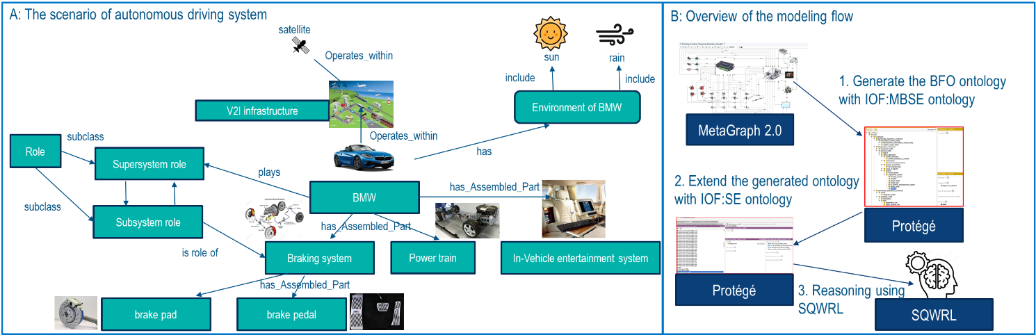

Figure 6 An autonomous driving system and evaluation process

As shown in Figure 6-A，an autonomous driving system use case is proposed as an example to demonstrate how the IOF SE ontology formalizes the use case. In the use case, a vehicle-to-infrastructure (V2I) is defined as a system of systems. There are two systems including satellite and BMW. The environment of BMW includes sun and rain (other elements are not considered). The BMW has braking system, power train and in-vehicle entertainment system as subsystems. Moreover, the braking system has two components: brake pad and brake pedal. In order to evaluate the proposed ontology based on the case study, a modeling flow is developed to develop the ontology model based on the given ontology semi-automatically. First, architecture models of vehicles and its SoS are developed in MetaGraph 2.0. The generated ontology model is defined based on the GOPPRRE ontology which is extended under the BFO ontology framework. Then the IOF:SE ontology is developed in the generated ontology model. Finally, a semantic reasoning is implemented based on the ontology model using SQWRL.

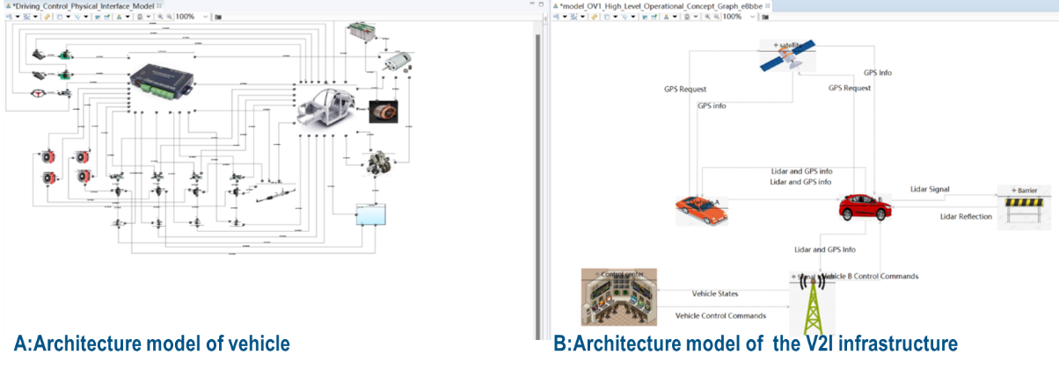

Figure 7 Architecture model of the autonomous driving system

As shown in Figure 7，the architecture model of the BMW are developed in MetaGraph 2.0 (Lu et al. 2021) by using two specific modeling diagrams: A: internal block diagram; B:UPDM OV1 diagram. The architecture model A represents the structure of *BMW* in Figure 6. The architecture model B represents the entire *SoS V2I infrastructure*. Moreover, vehicle A represent the BMW in Figure 6. The details of the model are shown in the article (Jinzhi et al. 2022).

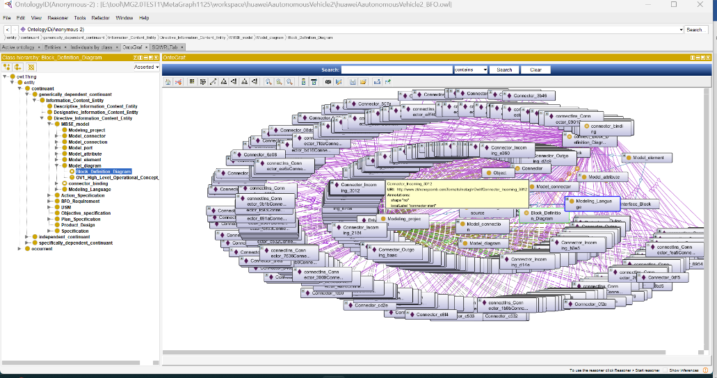

Figure 8 Ontology model of Architecture model of the autonomous driving system based on BFO

By using MetaGraph 2.0, an ontology model (Figure 8) is generated from the architecture models within the Figure 8. The ontology model in Figure 9 is combined with the ontology model in Figure 8 under the BFO ontology. The generated ontology model is extended based on the IOF:SE ontology and individuals are added in order to define the autonomous driving system. Finally, the individuals representing the system model entities and the individuals representing the autonomous driving system are connected by using different object properties, such as the model of the V2I infrastructure *represent* (object property) BMW in Figure 10.

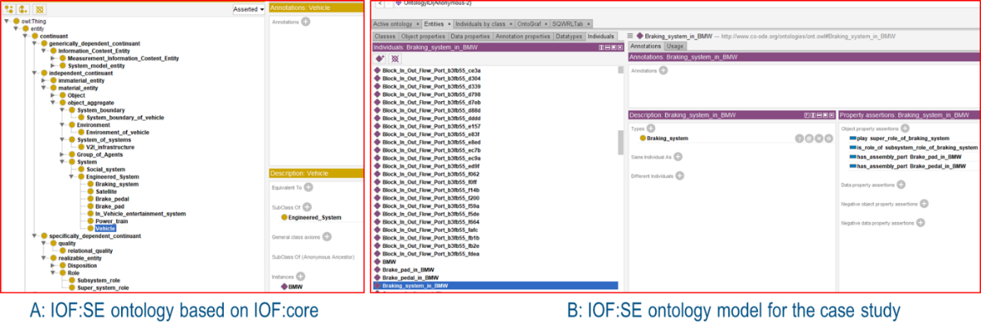

Figure 9 Ontology class and individuals to formalize the case study

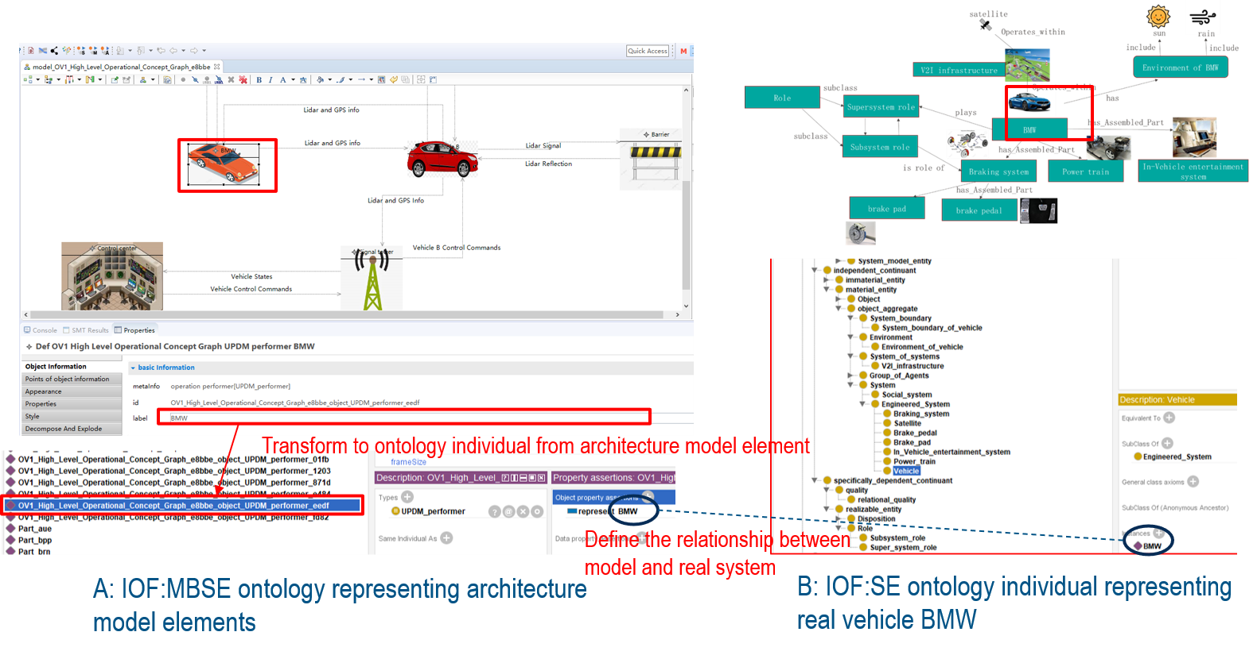

Figure 10 Combining the ontology models of MBSE model and real system

Through the combined ontology model, semantic reasoning can be used to provide some analysis based on the architecture model. For example, if the system developers want to know what is the environment of the BMW based on the model Figure 10:A, a semantic reasoning rule is defined as follow using SQWRL, as shown in Figure 11:A:

OV1_High_Level_Operational_Concept_Graph (?sosModel) ^graphIncludingObject (?sosModel, ?modelElement) ^sqwrl:makeSet(?modelElementSet, ?modelElement) ^ vehicle(?veh)^represent(?vehicleModelEle, ?veh)^sqwrl:makeSet(?vehicleModelEleSet, ?vehicleModelEle)^sqwrl:difference(?environEleSet, ? vehicleModelEleSet,? modelElementSet)^sqwrl:element(?environmentElement, ?environEleSet)^sqwrl:size(?size, ?environEleSet)→ sqwrl:select(?environmentElement,?size)

This reasoning rule captures the environmental elements through the following process:

1. One individual collection (*modelElementSet*) containing all the objects in the system of system architecture model is generated by the built-in operators “*sqwrl:makeSet*”.
2. Another individual collection (*vehicleModelEleSet*) containing all the “vehicle” class individuals in the system of system architecture model is also generated by the built-in operators “*sqwrl:makeSet*”.
3. The built-in operator “*sqwrl:difference*” provides negation of *vehicleModelEleSet* in *modelElementSet*. Thus, all the elements except the object representing “BMW” are captured, which can be considered as the environment of the BMW.
4. The built-in operator “*sqwrl:size*” can provide the number of elements in this environment.

After reasoning, the results are shown in Figure 11:B. The elements of BMW environment are all listed including the satellite, signal tower, control center and so on. The number of the environment elements are also provided to support the quantitative analysis, which is 5.



Figure 11 Semantic reasoning for the environment of the BMW

# Discussion

Evaluation. From the case study, we find the real autonomous driving system and its architecture model are defined in a unified ontology based on BFO. Through this ontology, the topology between the real system and its virtual models is defined as a basis which enables to implement semantic reasoning for further model analysis and decision-makings. Using the top level ontology, it provides a potential solution for integrating the domain specific knowledge and constructing a unified world vision for the AI-driven systems in order to develop cognition services for digital twins. Moreover, the unified ontology provides a bridge between the real system and their virtual models, which provide readable information for the AI system to describe and to distinguish the virtual model and the real world separately.

The proposed ontology provides better scalability to extend other domain ontology and application ontology in the future: 1) the adopted BFO and IOF:core ontology is one of the most powerful top level ontologies, which has been published by the IOF (https://www.industrialontologies.org/); 2) the MBSE is defined based on the GOPPRRE approach, whose meta–meta models including Graph, Object, Relationship, Port, Role and Property have been proof as having excellent descriptive capabilities (Kern et al. 2011).

Prospect. In several EU and CN projects, such as H2020 Onto-commons (<https://ontocommons.eu/>), H2020 Qu4lity (<https://qu4lity-project.eu/>), the proposed IOF:SE and IOF:MBSE ontology is used for different industries, such as aircraft and aerospace.

Gap and limitation. The current system ontology entity is defined as a material entity in BFO and IOF:core. However, in the systems engineering community, system is also defined as a “concept” which is not a material entity. Thus, the requirements to promote the top level ontology BFO and IOF:core are provided by the systems engineering working group.

Future work and plan. The IOF:SE ontology and IOF: MBSE ontology will be continuously developed for further evaluation. First, the ontology concepts on the domain of systems engineering and MBSE will extended, particularly on system lifecycle, system requirement and digital twin. Second, open source tools are planned to develop in order to support a more user-friendly environment for ontology users. Suggestions will continue to be provide to IOF:core and BFO community for developing a more powerful top level ontology.

# Conclusion

In this paper, we proposed a domain ontology based on top level ontology IOF:core and Basic formal ontology that supports systems engineering formalism and model-based systems engineering formalism. First, we introduce an overview of IOF Systems Engineering and MBSE ontology. Then specifically, IOF systems engineering ontology concepts are proposed. In order to evaluate the proposed ontology, an autonomous driving system is proposed as a case study and an ontology model is built to evaluate the proposed ontology. From the discussion, we conclude top-level ontology is beneficial to integrate the ontology for virtual entity and physical entity which should be developed separately. In the future, a more complex scenario will be designed to formalize the physical system and their architecture models using a unified ontology.

# Acknowledgement

The work presented in this paper has been partially supported by the EU H2020 project FACTLOG (869951) - Energy-aware Factory Analytics for Process Industries and EU H2020 project OntoCommons Ontology-driven data documentation for Industry Commons (958371). The authors would like to thank the IoF Systems Engineering Working Group (SEWG 2020) .

# References

Arp R, Smith B, Spear AD (2016) Building Ontologies with Basic Formal Ontology. The MIT Press, Cambridge

Dong M, Lu J, Wang G, et al (2022) Model-based Systems Engineering Papers Analysis based on Word Cloud Visualization. In: 2022 IEEE International Systems Conference (SysCon). IEEE, pp 1–7

Dori D, Sillitto H (2017) What is a System? An Ontological Framework. Syst Eng 20:207–219. https://doi.org/10.1002/sys.21383

Fanmuy G, Salinesi C, Hammami O, et al (2010) Requirements Analysis and Modeling Process (RAMP) for the Development of Complex Systems. INCOSE Int Symp 20:557–579. https://doi.org/10.1002/j.2334-5837.2010.tb01089.x

Fisher A, Nolan M, Friedenthal S, et al (2014) Model Lifecycle Management for MBSE. INCOSE Int Symp 24:207–229. https://doi.org/10.1002/j.2334-5837.2014.tb03145.x

Friedenthal S (2016) Evolving Sysml and the System Modeling Environment To Support Mbse - Part 2. Insight 19:76–80. https://doi.org/10.1002/inst.12134

Henderson K, Salado A (2020) Value and benefits of model-based systems engineering (MBSE): Evidence from the literature. Syst Eng 1–16. https://doi.org/10.1002/sys.21566

IEEE Standard (2011) INTERNATIONAL STANDARD ISO / IEC / IEEE Systems and software engineering - Architecture description

ISO/IEC/IEEE (2008) Systems and software engineering System life cycle processes

Jinzhi L, Zhaorui Y, Xiaochen Z, et al (2022) Exploring the concept of Cognitive Digital Twin from model-based systems engineering perspective. Int J Adv Manuf Technol 121:5835–5854. https://doi.org/10.1007/s00170-022-09610-5

Jinzhi Lu, Guoxin Wang MT Design Ontology to Support Co-simulation Automation in a Model-based Systems Engineering Tool-chain. IEEE Syst J

Kern H, Hummel A, Kühne S (2011) Towards a comparative analysis of meta-metamodels. In: SPLASH’11 Workshops - Compilation Proceedings of the Co-Located Workshops: DSM’11, TMC’11, AGERE’11, AOOPES’11, NEAT’11, and VMIL’11. ACM Press, New York, New York, USA, pp 7–12

Levenchuk A (2009) SysML is the Point of Departure for MBSE, Not the Destination. Insight 12:54–55. https://doi.org/10.1002/inst.200912454

Li Z, Wang G, Lu J, et al (2022) Bibliometric Analysis of Model-Based Systems Engineering: Past, Current, and Future. IEEE Trans Eng Manag 1–18. https://doi.org/10.1109/TEM.2022.3186637

Lu J, Ma J, Zheng X, et al (2021) Design Ontology Supporting Model-Based Systems Engineering Formalisms. IEEE Syst J 14:1–12. https://doi.org/10.1109/JSYST.2021.3106195

Madni AM (2015) Expanding Stakeholder Participation in Upfront System Engineering through Storytelling in Virtual Worlds. Syst Eng 18:16–27. https://doi.org/10.1002/sys.21284

Martin JN (2021) Overview of the Revised Standard on Architecture Description – ISO/IEC 42010. INCOSE Int Symp 31:1363–1376. https://doi.org/10.1002/j.2334-5837.2021.00906.x

Menshenin Y, Crawley E (2020) A system concept representation framework and its testing on patents, urban architectural patterns, and software patterns. Syst Eng 23:492–515. https://doi.org/10.1002/sys.21547

Nilsson R, Dori D, Jayawant Y, et al (2020) Towards an Ontology for Collaboration in System of Systems Context. INCOSE Int Symp 30:666–679. https://doi.org/10.1002/j.2334-5837.2020.00747.x

Petnga L, Austin M, Blackburn M (2017) Semantically-enabled Model-based Systems Engineering of Safety-critical Network of Systems. INCOSE Int Symp 27:487–501. https://doi.org/10.1002/j.2334-5837.2017.00374.x

SEWG I (2020) IOF Systems Engineering Working Group. https://industrialontologies.org/systems-engineering-wg/

Shaked A, Reich Y (2019) Designing development processes related to system of systems using a modeling framework. Syst Eng 22:561–575. https://doi.org/10.1002/sys.21512

Sharon A, de Weck OL, Dori D (2009) Is There a Complete Project Plan? A Model-Based Project Planning Approach. INCOSE Int Symp 19:96–109. https://doi.org/10.1002/j.2334-5837.2009.tb00940.x

Strengers G (2014) A Structure for Model-Based Concept Design. INSIGHT 17:29–32. https://doi.org/10.1002/inst.201417429

# Biography

|  |  |
| --- | --- |
| Jinzhi Lu | CSEP, is a research scientist at EPFL. He received his PhD at KTH Royal Institute of Technology, Mechatronics Division in 2019. His research interest is MBSE tool-chain design and MBSE enterprise transitioning. |
| Barry Smith |  |
| Chris Will |  |
| Jim Logan |  |
| David Carmon |  |
| Joe Gregory |  |
| Yves Keraron |  |
| Zhengchao Hu |  |
| Dimitris Kiritsis |  |

1. <https://incose.onlinelibrary.wiley.com/>
2. https://industrialontologies.org/